Output file

________________________________________________________________________________
CASE 1. Starting server with no existing registry
________________________________________________________________________________

Server
Creating new registry
Server started...

________________________________________________________________________________
CASE 2. Trying to read from empty registry
________________________________________________________________________________

Client
Started listening on port : 9898
Peer Client
Menu:
1. Register file list 2. Register directory on server
3. Add file 4. Delete file
5. Search file 6. Download
7. Exit
6
Enter file name to download:
sam.txt

Server
Thread-0
Received request from : 9898/10.0.0.4
No results found
Current Registry :
Registry
[
fileIndex=null
]

________________________________________________________________________________
CASE 3. Registering one file on server
________________________________________________________________________________

Client
Menu:
1. Register file list 2. Register directory on server
3. Add file 4. Delete file
5. Search file 6. Download
7. Exit

1
Enter file names separated by comma ',' and no spaces in between (e.g. : a.txt,b.txt) :
Registry.txt

Server

Thread-2
Received request from : 9898/10.0.0.4
Current Registry :
Registry
[
fileIndex={Registry.txt=[ [ IP : 10.0.0.4, Port : 9898, Bandwidth=-1 ]
]}
]

________________________________________________________________________________
CASE 4. Registering multiple files on server
________________________________________________________________________________

Client

Peer Client
Menu:
1. Register file list 2. Register directory on server
3. Add file 4. Delete file
5. Search file 6. Download
7. Exit
1
Enter file names separated by comma ',' and no spaces in between (e.g. : a.txt,b.txt) :
a.txt,b.txt,c.txt,d,exe

Server

Thread-3
Received request from : 9898/10.0.0.4
Current Registry :
Registry
[
fileIndex={b.txt=[ [ IP : 10.0.0.4, Port : 9898, Bandwidth=-1 ]
], a.txt=[ [ IP : 10.0.0.4, Port : 9898, Bandwidth=-1 ]
], exe=[ [ IP : 10.0.0.4, Port : 9898, Bandwidth=-1 ]
], d=[ [ IP : 10.0.0.4, Port : 9898, Bandwidth=-1 ]
], Registry.txt=[ [ IP : 10.0.0.4, Port : 9898, Bandwidth=-1 ]
], c.txt=[ [ IP : 10.0.0.4, Port : 9898, Bandwidth=-1 ]
]}
]

________________________________________________________________________________
CASE 5. Registering entire directory files on server
________________________________________________________________________________

Client
Peer Client
Menu:
1. Register file list 2. Register directory on server
3. Add file 4. Delete file
5. Search file 6. Download
7. Exit
2
Files in folder : ,a.pdf,Registry.java

Server

Thread-4
Received request from : 9898/10.0.0.4
Current Registry :
Registry
[
fileIndex={b.txt=[ [ IP : 10.0.0.4, Port : 9898, Bandwidth=-1 ]
], =[ [ IP : 10.0.0.4, Port : 9898, Bandwidth=-1 ]
], a.txt=[ [ IP : 10.0.0.4, Port : 9898, Bandwidth=-1 ]
], exe=[ [ IP : 10.0.0.4, Port : 9898, Bandwidth=-1 ]
], d=[ [ IP : 10.0.0.4, Port : 9898, Bandwidth=-1 ]
], Registry.txt=[ [ IP : 10.0.0.4, Port : 9898, Bandwidth=-1 ]
], c.txt=[ [ IP : 10.0.0.4, Port : 9898, Bandwidth=-1 ]
], a.pdf=[ [ IP : 10.0.0.4, Port : 9898, Bandwidth=-1 ]
], Registry.java=[ [ IP : 10.0.0.4, Port : 9898, Bandwidth=-1 ]
]}
]

________________________________________________________________________________
CASE 6. Client exiting
________________________________________________________________________________

Client
Started listening on port : 9898
Peer Client
Menu:
1. Register file list 2. Register directory on server
3. Add file 4. Delete file
5. Search file 6. Download
7. Exit
7
THANK YOU!!

________________________________________________________________________________
CASE 7 : Assuming server somehow failed. In this case we need to recover registry. Thus reading the persistent object of registry saved after last successfully run operation ________________________________________________________________________________
Server

Registry
[
fileIndex={b.txt=[ [ IP : 10.0.0.4, Port : 9898, Bandwidth=-1 ]
], =[ [ IP : 10.0.0.4, Port : 9898, Bandwidth=-1 ]
], a.txt=[ [ IP : 10.0.0.4, Port : 9898, Bandwidth=-1 ]
], exe=[ [ IP : 10.0.0.4, Port : 9898, Bandwidth=-1 ]
], d=[ [ IP : 10.0.0.4, Port : 9898, Bandwidth=-1 ]
], Registry.txt=[ [ IP : 10.0.0.4, Port : 9898, Bandwidth=-1 ]
], c.txt=[ [ IP : 10.0.0.4, Port : 9898, Bandwidth=-1 ]
], a.pdf=[ [ IP : 10.0.0.4, Port : 9898, Bandwidth=-1 ]
], Registry.java=[ [ IP : 10.0.0.4, Port : 9898, Bandwidth=-1 ]
]}
]

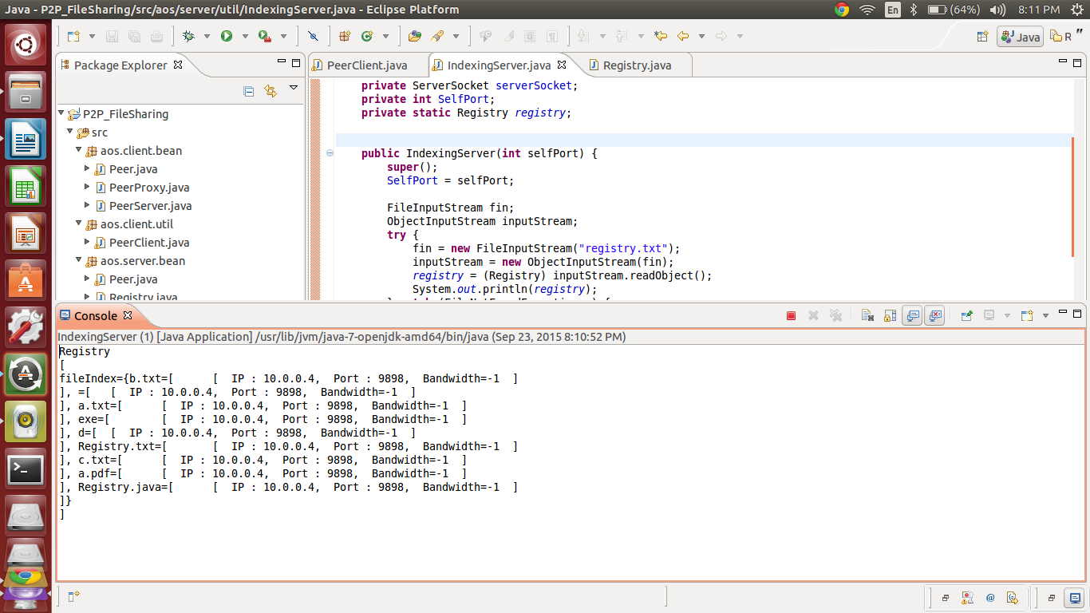

________________________________________________________________________________
CASE 8. Searching non existing file
________________________________________________________________________________

Client
Started listening on port : 9898
Peer Client
Menu:
1. Register file list 2. Register directory on server
3. Add file 4. Delete file
5. Search file 6. Download
7. Exit
5
Enter file name to search:
XYZ
File not found

Server
Thread-0
Received request from : 9898/10.0.0.4
No results found
Current Registry :
Registry
[
fileIndex={b.txt=[ [ IP : 10.0.0.4, Port : 9898, Bandwidth=-1 ]
], =[ [ IP : 10.0.0.4, Port : 9898, Bandwidth=-1 ]
], a.txt=[ [ IP : 10.0.0.4, Port : 9898, Bandwidth=-1 ]
], exe=[ [ IP : 10.0.0.4, Port : 9898, Bandwidth=-1 ]
], d=[ [ IP : 10.0.0.4, Port : 9898, Bandwidth=-1 ]
], Registry.txt=[ [ IP : 10.0.0.4, Port : 9898, Bandwidth=-1 ]
], c.txt=[ [ IP : 10.0.0.4, Port : 9898, Bandwidth=-1 ]
], a.pdf=[ [ IP : 10.0.0.4, Port : 9898, Bandwidth=-1 ]
], Registry.java=[ [ IP : 10.0.0.4, Port : 9898, Bandwidth=-1 ]
]}
]

________________________________________________________________________________
CASE 9. Searching an existing file
________________________________________________________________________________

Client
Peer Client
Menu:
1. Register file list 2. Register directory on server
3. Add file 4. Delete file
5. Search file 6. Download
7. Exit
5
Enter file name to search:
a.pdf
[ [ IP : 10.0.0.4, Port : 9898, Bandwidth=-1 ]
]

Server
Thread-1
Received request from : 9898/10.0.0.4
[ [ IP : 10.0.0.4, Port : 9898, Bandwidth=-1 ]
]
Current Registry :
Registry
[
fileIndex={b.txt=[ [ IP : 10.0.0.4, Port : 9898, Bandwidth=-1 ]
], =[ [ IP : 10.0.0.4, Port : 9898, Bandwidth=-1 ]
], a.txt=[ [ IP : 10.0.0.4, Port : 9898, Bandwidth=-1 ]
], exe=[ [ IP : 10.0.0.4, Port : 9898, Bandwidth=-1 ]
], d=[ [ IP : 10.0.0.4, Port : 9898, Bandwidth=-1 ]
], Registry.txt=[ [ IP : 10.0.0.4, Port : 9898, Bandwidth=-1 ]
], c.txt=[ [ IP : 10.0.0.4, Port : 9898, Bandwidth=-1 ]
], a.pdf=[ [ IP : 10.0.0.4, Port : 9898, Bandwidth=-1 ]
], Registry.java=[ [ IP : 10.0.0.4, Port : 9898, Bandwidth=-1 ]
]}
]
________________________________________________________________________________
CASE 10. Deleting file entry from registry. This will allow only to remove files registered by the same Peer. If other instance of file exists on other peer then that entry will not be allowed to be removed by this instance.
________________________________________________________________________________

Client
Peer Client
Menu:
1. Register file list 2. Register directory on server
3. Add file 4. Delete file
5. Search file 6. Download
7. Exit
4
Enter file name to delete from server :
c.txt

Server
Thread-2
Received request from : 9898/10.0.0.4
Current Registry :
Registry
[
fileIndex={b.txt=[ [ IP : 10.0.0.4, Port : 9898, Bandwidth=-1 ]
], =[ [ IP : 10.0.0.4, Port : 9898, Bandwidth=-1 ]
], a.txt=[ [ IP : 10.0.0.4, Port : 9898, Bandwidth=-1 ]
], exe=[ [ IP : 10.0.0.4, Port : 9898, Bandwidth=-1 ]
], d=[ [ IP : 10.0.0.4, Port : 9898, Bandwidth=-1 ]
], Registry.txt=[ [ IP : 10.0.0.4, Port : 9898, Bandwidth=-1 ]
], a.pdf=[ [ IP : 10.0.0.4, Port : 9898, Bandwidth=-1 ]
], Registry.java=[ [ IP : 10.0.0.4, Port : 9898, Bandwidth=-1 ]
]}
]

________________________________________________________________________________
CASE 11. Searching for a file
________________________________________________________________________________

Client
Peer Client
Menu:
1. Register file list 2. Register directory on server
3. Add file 4. Delete file
5. Search file 6. Download
7. Exit
5
Enter file name to search:
a.pdf
1 [ IP : 10.0.0.4, Port : 9898, Bandwidth=-1 ]

Server

Thread-3
Received request from : 9898/10.0.0.4
[ [ IP : 10.0.0.4, Port : 9898, Bandwidth=-1 ]
]
Current Registry :
Registry
[
fileIndex={b.txt=[ [ IP : 10.0.0.4, Port : 9898, Bandwidth=-1 ]
], =[ [ IP : 10.0.0.4, Port : 9898, Bandwidth=-1 ]
], a.txt=[ [ IP : 10.0.0.4, Port : 9898, Bandwidth=-1 ]
], exe=[ [ IP : 10.0.0.4, Port : 9898, Bandwidth=-1 ]
], d=[ [ IP : 10.0.0.4, Port : 9898, Bandwidth=-1 ]
], Registry.txt=[ [ IP : 10.0.0.4, Port : 9898, Bandwidth=-1 ]
], a.pdf=[ [ IP : 10.0.0.4, Port : 9898, Bandwidth=-1 ]
], Registry.java=[ [ IP : 10.0.0.4, Port : 9898, Bandwidth=-1 ]
]}
]

________________________________________________________________________________
CASE 12. Downloading a file
________________________________________________________________________________

Client
Peer Client
Menu:
1. Register file list 2. Register directory on server
3. Add file 4. Delete file
5. Search file 6. Download
7. Exit
6
Enter file name to download:
a.pdf
1 [ IP : 10.0.0.4, Port : 9898, Bandwidth=-1 ]

Trying to download from server : [ IP : 10.0.0.4, Port : 9898, Bandwidth=-1 ]

File a.pdf downloaded (71850367 bytes read)

Server
Received request from : 9898/10.0.0.4
[ [ IP : 10.0.0.4, Port : 9898, Bandwidth=-1 ]
]
Current Registry :
Registry
[
fileIndex={b.txt=[ [ IP : 10.0.0.4, Port : 9898, Bandwidth=-1 ]
], =[ [ IP : 10.0.0.4, Port : 9898, Bandwidth=-1 ]
], a.txt=[ [ IP : 10.0.0.4, Port : 9898, Bandwidth=-1 ]
], exe=[ [ IP : 10.0.0.4, Port : 9898, Bandwidth=-1 ]
], d=[ [ IP : 10.0.0.4, Port : 9898, Bandwidth=-1 ]
], Registry.txt=[ [ IP : 10.0.0.4, Port : 9898, Bandwidth=-1 ]
], a.pdf=[ [ IP : 10.0.0.4, Port : 9898, Bandwidth=-1 ]
], Registry.java=[ [ IP : 10.0.0.4, Port : 9898, Bandwidth=-1 ]
]}
]

Peer Client
Started listening on port : 9898
Received request for : a.pdf
Request received : Socket[addr=/10.0.0.4,port=34999,localport=9898]
Size : 71850367
Sending a.pdf
File sent successfully.
________________________________________________________________________________
CASE 13. Downloading request for a non existing file
________________________________________________________________________________

Client
Peer Client
Menu:
1. Register file list 2. Register directory on server
3. Add file 4. Delete file
5. Search file 6. Download
7. Exit
6
Enter file name to download:
ebguguaegge
File not found
File not found

Server

Received request from : 9898/10.0.0.4
No results found
Current Registry :
Registry
[
fileIndex={b.txt=[ [ IP : 10.0.0.4, Port : 9898, Bandwidth=-1 ]
], =[ [ IP : 10.0.0.4, Port : 9898, Bandwidth=-1 ]
], a.txt=[ [ IP : 10.0.0.4, Port : 9898, Bandwidth=-1 ]
], exe=[ [ IP : 10.0.0.4, Port : 9898, Bandwidth=-1 ]
], d=[ [ IP : 10.0.0.4, Port : 9898, Bandwidth=-1 ]
], Registry.txt=[ [ IP : 10.0.0.4, Port : 9898, Bandwidth=-1 ]
], a.pdf=[ [ IP : 10.0.0.4, Port : 9898, Bandwidth=-1 ]
], Registry.java=[ [ IP : 10.0.0.4, Port : 9898, Bandwidth=-1 ]
]}
]

________________________________________________________________________________
CASE 14. Wrong input by client
________________________________________________________________________________

Client
Peer Client
Menu:
1. Register file list 2. Register directory on server
3. Add file 4. Delete file
5. Search file 6. Download
7. Exit
dg
Please enter correct choice
Peer Client
Menu:
1. Register file list 2. Register directory on server
3. Add file 4. Delete file
5. Search file 6. Download
7. Exit

________________________________________________________________________________
CASE 15. Exiting
________________________________________________________________________________

Client
Peer Client
Menu:
1. Register file list 2. Register directory on server
3. Add file 4. Delete file
5. Search file 6. Download
7. Exit
7
THANK YOU!!

